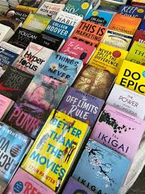 **"Unbeatable Deals. Unmatched Quality. Only at Novel Mart!"**

**Step into a world where shopping meets wonder—Novel Mart isn’t just a store, it’s an experience. From everyday essentials to rare finds you didn’t know you needed, we’ve curated a collection that turns routine errands into unexpected adventures. Whether you're chasing the latest trends or timeless classics, Novel Mart delivers more than products—it delivers stories. Come explore, discover, and let your next chapter begin here.**